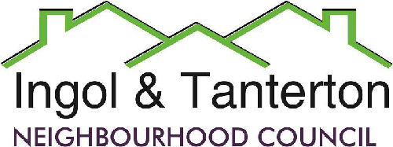

Gill Mason - Clerk and RFO

Email: [ingoltantertonnc@hotmail.co.uk](mailto:ingoltantertonnc@hotmail.co.uk)

**Agenda**

**A meeting of the Ingol and Tanterton Neighbourhood Council Area Enhancement Committee will be held on Wednesday 17th July 2024 at 6pm at Tanterton Village Centre.**

**Open forum**

1.To receive apologies.

2.To consider the quotes for the Ingol Dip playpark equipment, bench plinths and viewing platforms.

3.To consider the next steps for the Ingol Dip grass cutting contract.

4.To consider the quantity and siting of picnic tables and benches.

5.To consider the update on the Tanterton Field barrier.

Press and public are welcome to attend.